**REAL-TIME RIVER WATER QUALITY MONITORING AND CONTROL SYSTEM**

**SPRINT-4**

**MIT APP INVERTOR:**

**FRONT END:**

**SCREEN-1:**

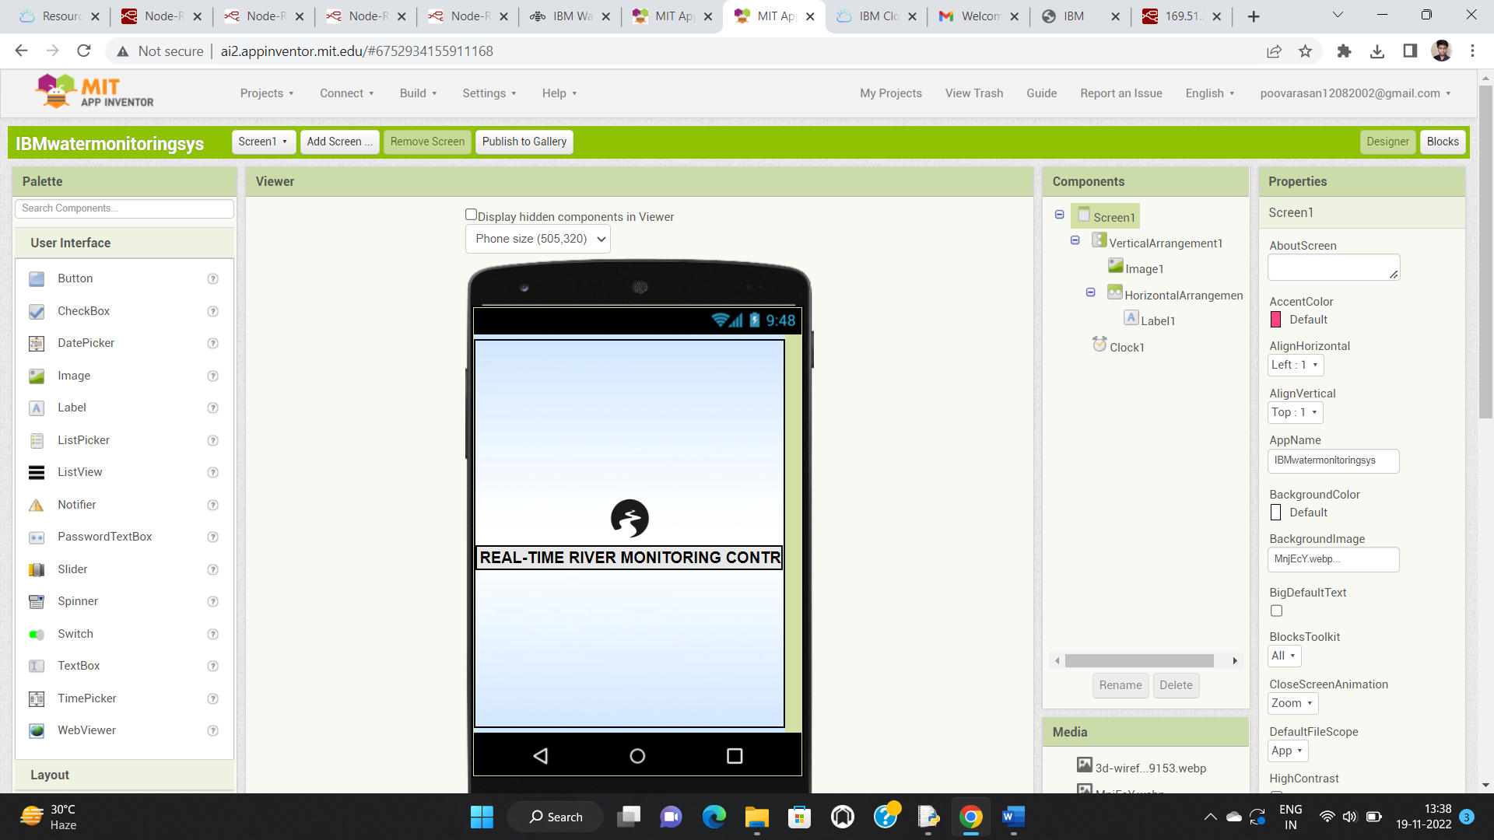

**SCREEN-2:**

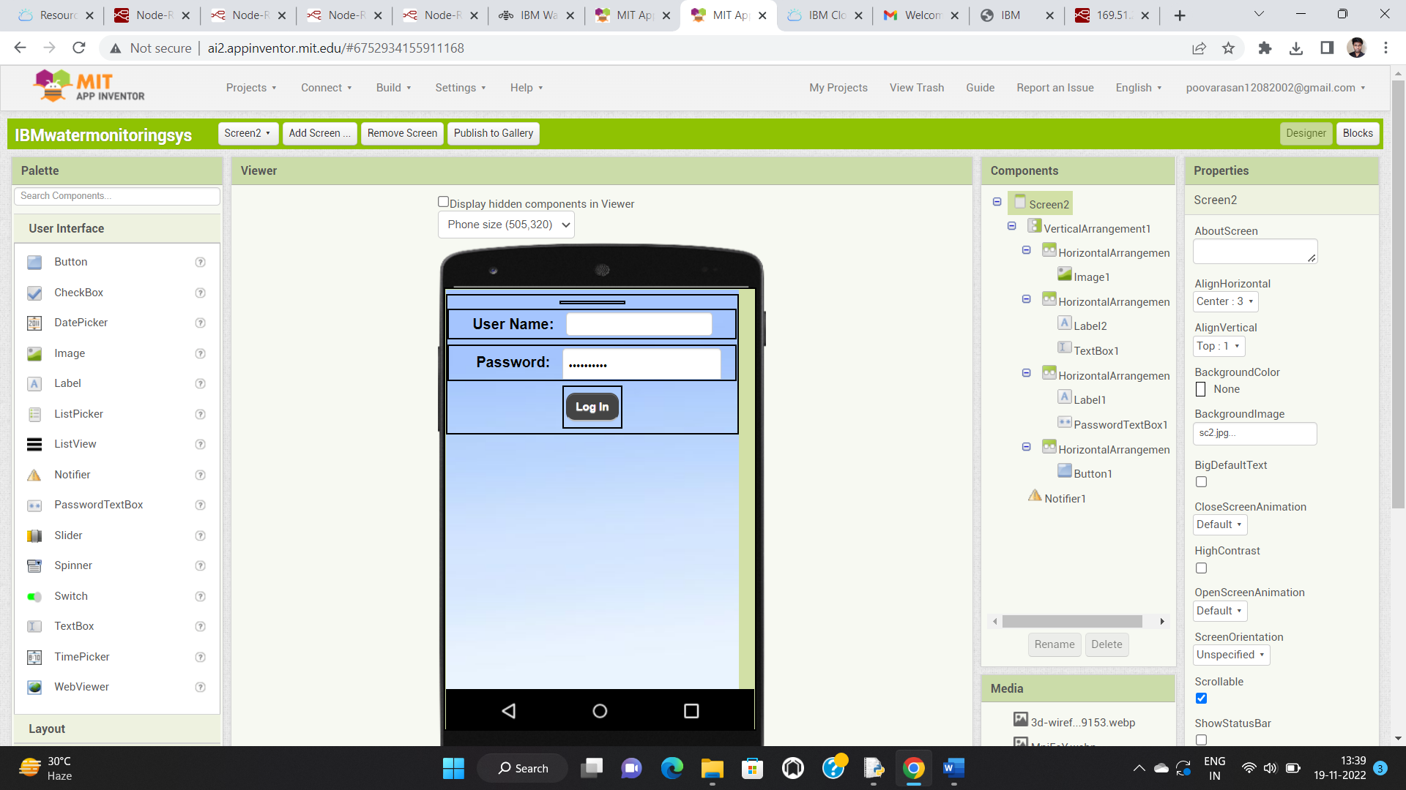

**SCREEN-3:**

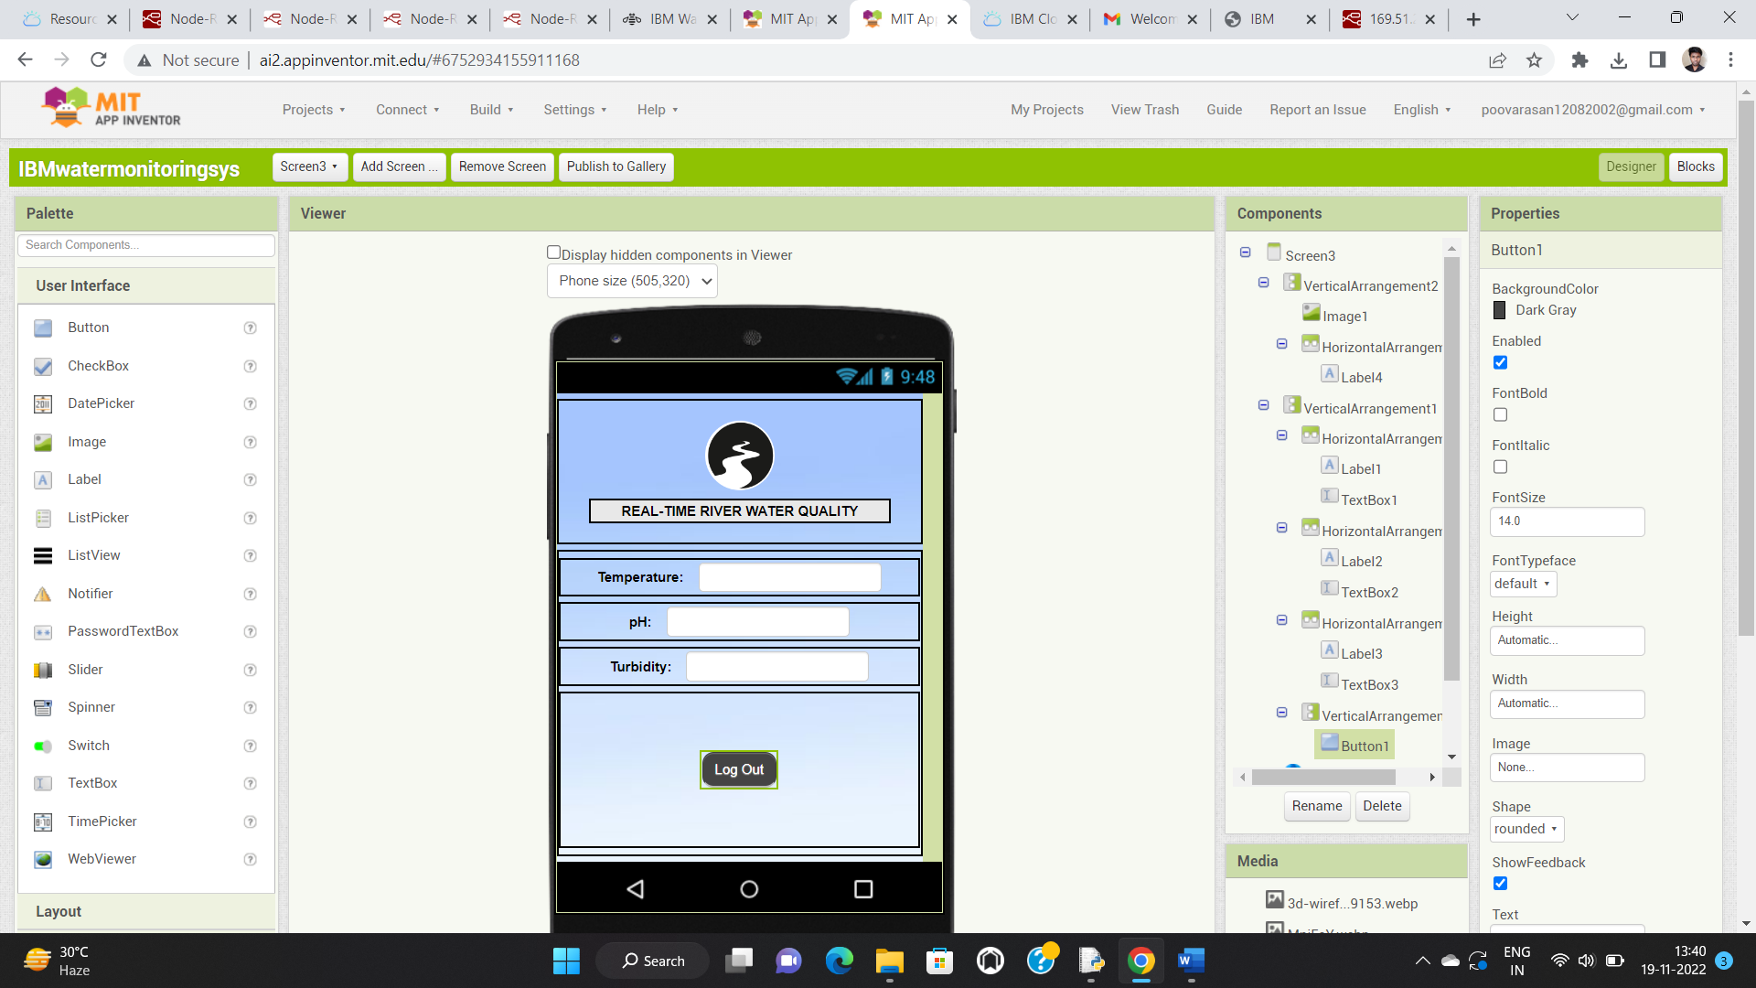

**BACK END:**

**SCREEN-1:**

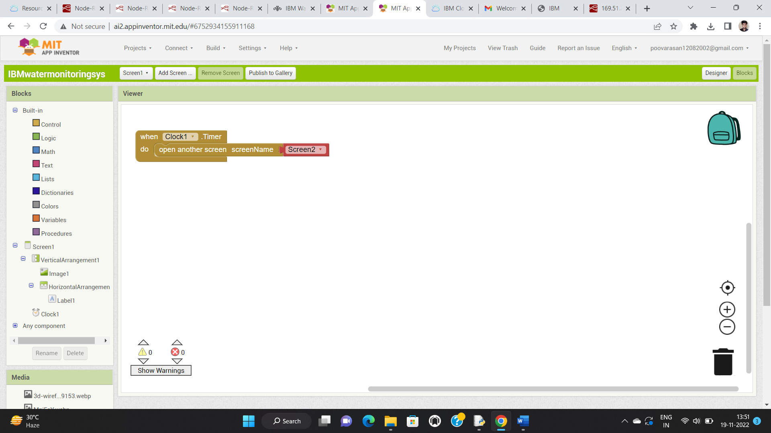

**SCREEN-2:**

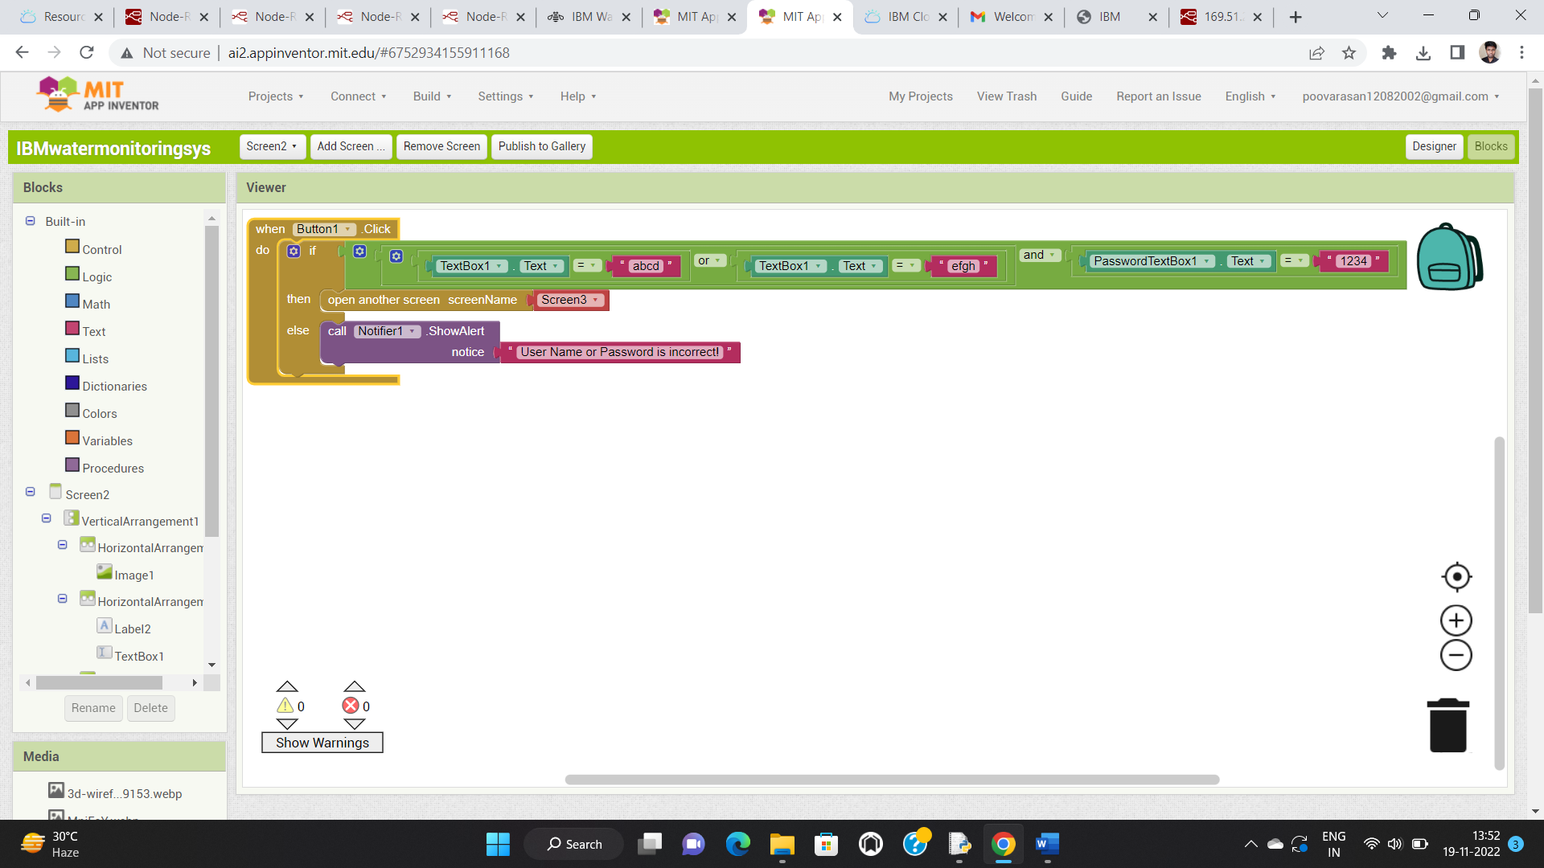

**SCREEN-3:**

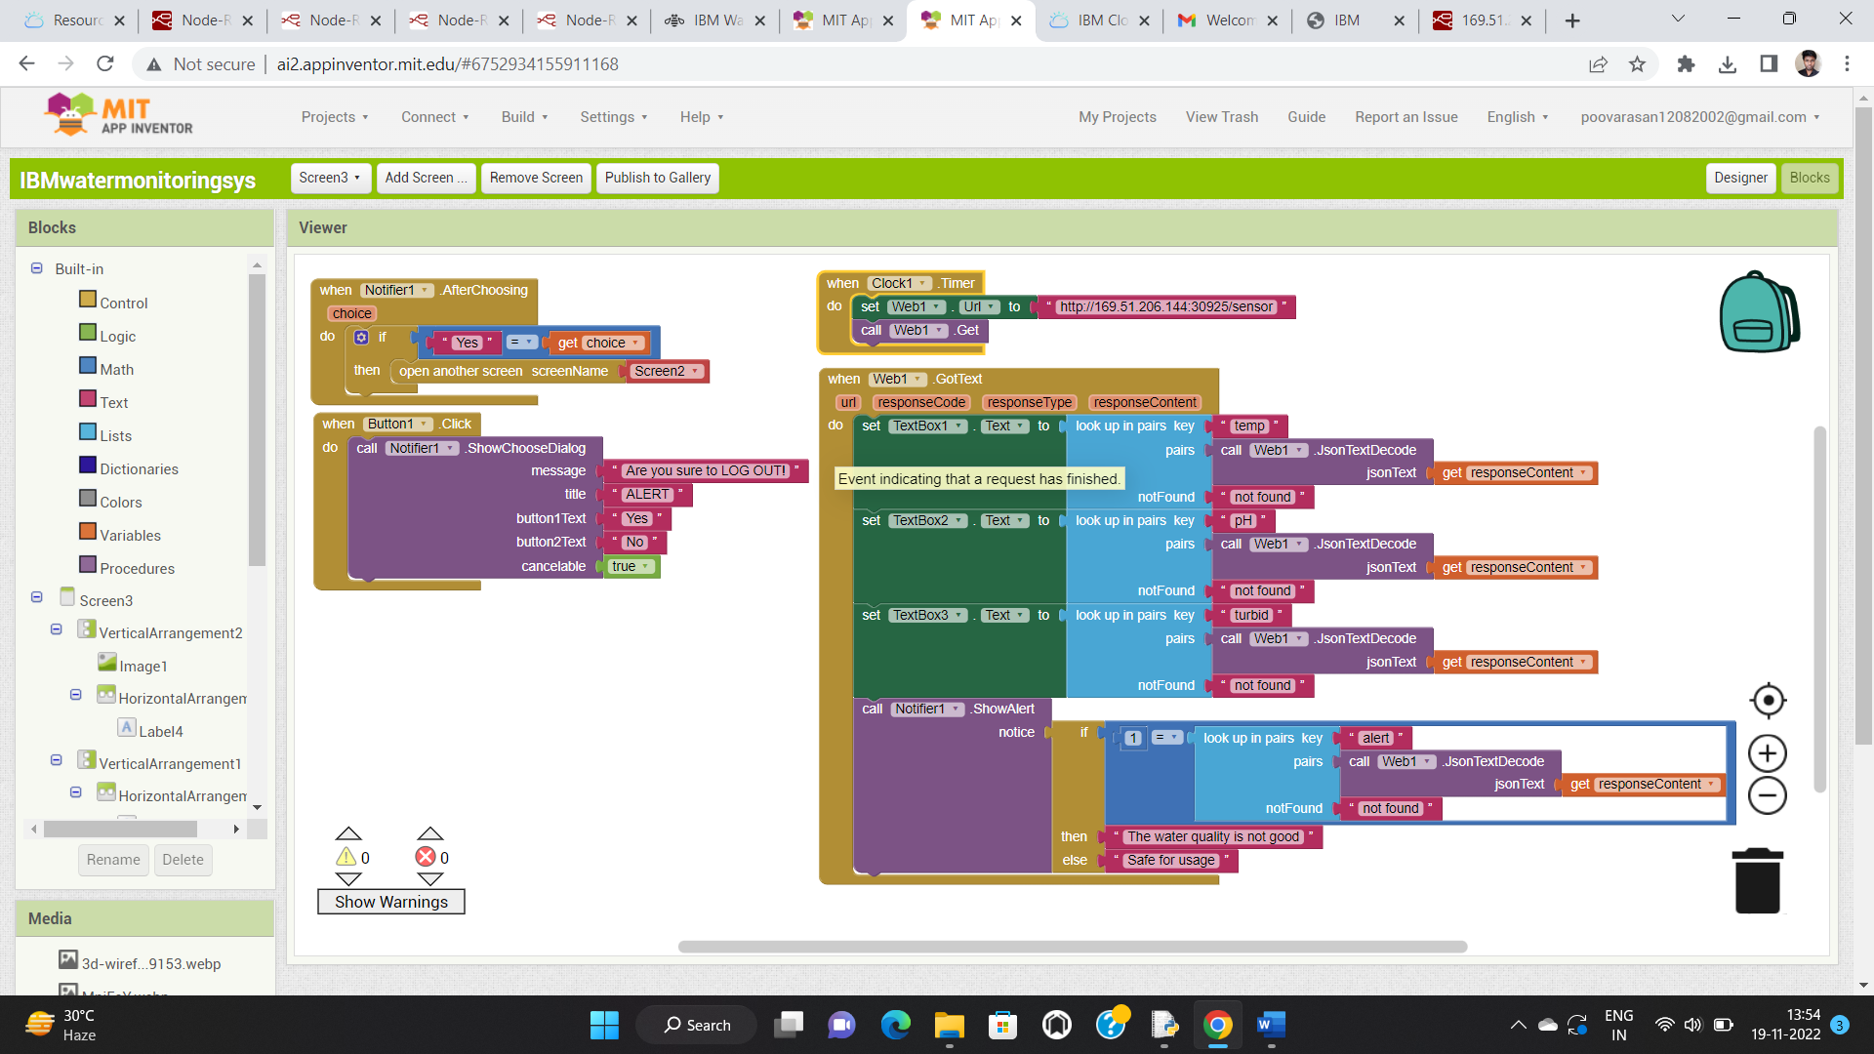

**MIT APP INVERTOR OUTPUT-MOBILE PHONE:**

**SCREEN-1: SCREEN-2:**

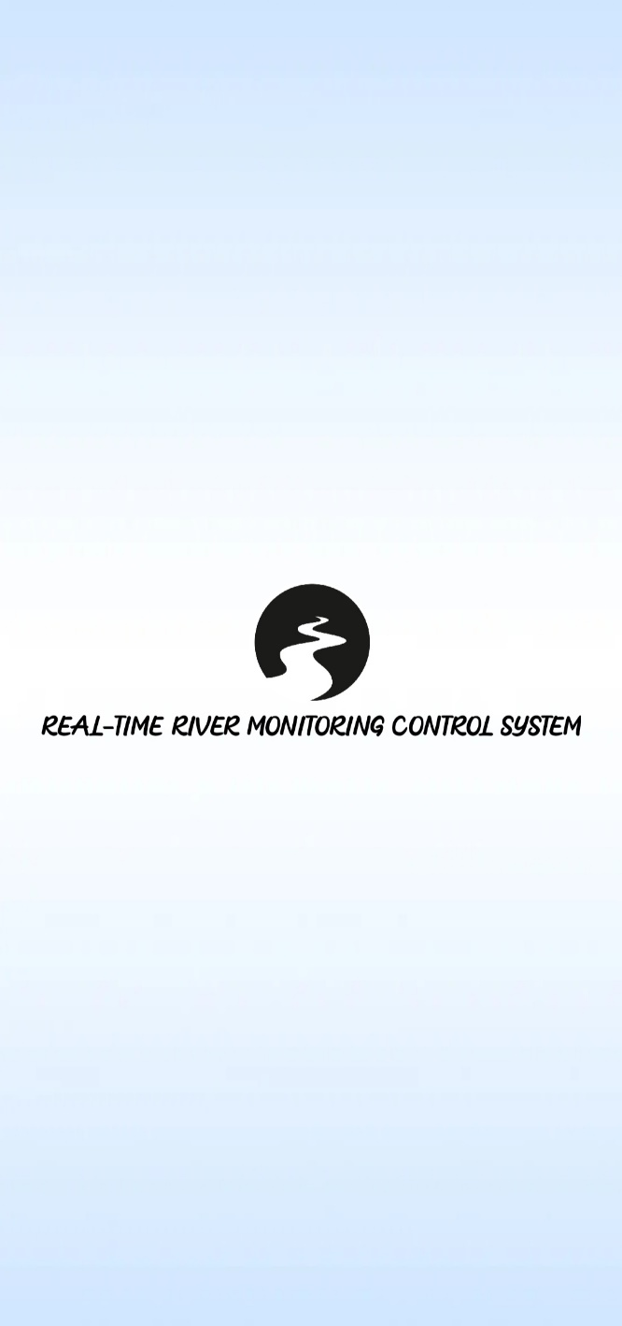 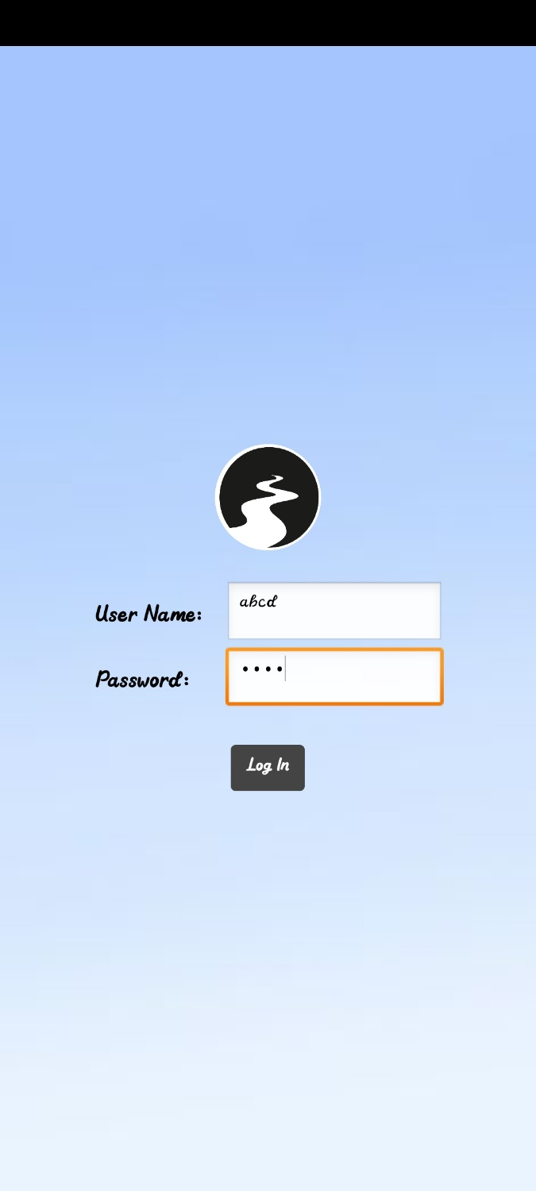

**SCREEN-3:**

If temperature>120, pH>6 and turbidity <500. If temperature<120, Ph<6 and turbidity>500.

The app shows “**SAFE FOR USAGE**”. The app shows “**THE WATER QUALITY**

**IS NOT GOOD**”.

